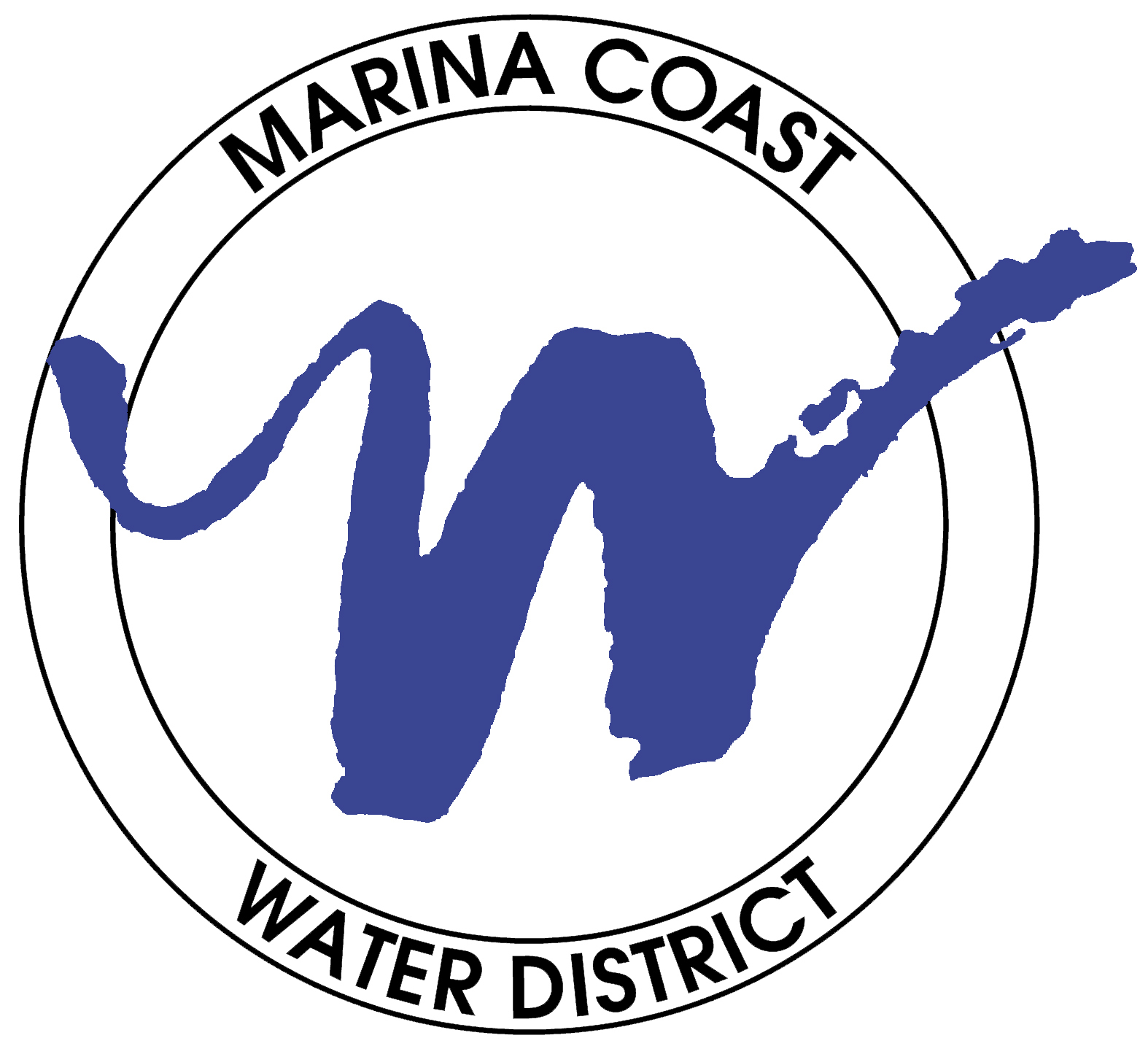
MARINA COAST WATER DISTRICT
DIRECTORS
WILLIAM Y. LEE
President

DAN BURNS
Vice President

HOWARD GUSTAFSON
KENNETH K. NISHI
JAN SHRINER

11 RESERVATION ROAD, MARINA, CA 93933-2099
Home Page: www.mcwd.org
TEL: (831) 384-6131 FAX: (831) 883-5995

Agenda
Special Board Meeting, Board of Directors
Marina Coast Water District
11 Reservation Road, Marina, California
Tuesday, March 29, 2011, 5:30 p.m.

This meeting has been noticed according to the Brown Act rules.

Mission: Providing high quality water, wastewater and recycled water services to the District’s expanding communities through management, conservation and development of future resources at reasonable costs.

Vision: The Marina Coast Water District will be the leading public supplier of integrated water and wastewater services in the Monterey Bay Region.

1. Call to Order

2. Roll Call

3. Closed Session

- Pursuant to Government Code Section 54957.6
Conference with Labor Negotiators
Agency designated representatives: William Lee and Dan Burns
Unrepresented employee: General Manager

7:00 p.m. Reconvene Open Session

4. Possible Action on Closed Session Items The Board will report out on any action taken during Closed Session, and may take additional action in Open Session, as appropriate. Any closed session items not completed will be discussed at the end of the meeting.

5. Pledge of Allegiance

6. Oral Communications Anyone wishing to address the Board on matters not appearing on the Agenda may do so at this time. Please limit your comment to three minutes. The public may comment on any other items listed on the agenda at the time they are considered by the Board.

7. Action Items

- Consider Adoption of Resolution No. 2011-20 to Authorize a Retainer Agreement with Dennis Kennelly, Esq. for Consulting Services Related to the Employment Contract of the General Manager

Action: The Board of Directors is requested to consider authorizing a Retainer Agreement with Dennis Kennelly, Esq. for Consulting Services Related to the Employment Contract of the General Manager.
(Page 01)

8. Budget Workshop

- Receive District Draft FY 2011-2012 Budgets, Rates, Fees and Charges for the Marina and Ord Community Service Areas and Provide Direction Regarding Preparation of the Final Budget Documents

Action: The Board of Directors will receive a brief presentation on the Draft FY 2011-2012 Budget and hold a workshop for discussion and providing direction regarding preparation of the final documents.
(Page 06)

9. Directors Comments

10. Adjournment Set or Announce Next Meeting(s), date(s), time(s), and location(s):

Regular Meeting: Tuesday, April 12, 2011, 6:45 p.m.,
11 Reservation Road, Marina

Marina Coast Water District
Agenda Transmittal

Agenda Item: 7A Meeting Date: March 29, 2011

Submitted By: Jean Premutati Presented By: Jean Premutati
Reviewed By: Carl Niizawa

Agenda Title: The Board is Requested to Consider Authorizing a Retainer Agreement with Dennis Kennelly, Esq. for Consulting Services Related to the Employment Contract of the General Manager

Background: The Board is requested to consider authorizing a retainer agreement with Dennis Kennelly, Esq. for consulting services related to the employment contract of the General Manager (GM). The initial employment contract between the GM and the District was signed August 8, 2007 and became effective September 10, 2007 with an automatic renewal period of three years. An amendment to the contract was negotiated between the GM and the District and signed on November 29, 2010. The amendment also contained a three-year renewal period.

In a subsequent review of the amendment, it was determined that Sections 2.1.3 and 5.1 require further clarification and explanation in order to comply with Internal Revenue Service (IRS) and government codes.

In order to ensure IRS compliance and adherence to applicable government codes, staff is recommending an additional review of the GM’s employment contract by Dennis Kennelly, Esq. Mr. Kennelly specializes in labor and employment law at the executive level and previously held the position of Labor Relations attorney for the San Francisco Chronicle and Labor Counsel for Tribune Company’s West Coast operations. Mr. Kennelly has been in private practice since 1985.

Prior Committee or Board Action: Amendment to employment contract in November 2010.

Environmental Review Compliance: None.

Board Goals/Objectives: Mission Statement – Providing high quality water, wastewater and recycled water services to the District’s expanding communities through management, conservation and development of future resources at reasonable costs.

Financial Impact: X Yes No

Funding Source/Recap: Administrative cost centers.

Material Included for Information/Consideration: Resolution No. 2011-20; Retainer Agreement with Dennis Kennelly, Esq.

Staff Recommendation: The Board of Directors adopt Resolution No. 2011-20 Authorizing a Retainer Agreement with Dennis Kennelly, Esq. for Consulting Services Related to the Employment Contract of the General Manager.

Action Required: X Resolution Motion Review
(Roll call vote is required.)

Board Action

Resolution No Motion By Seconded By

Ayes Abstained

Noes Absent

Reagendized Date No Action Taken

Resolution No. 2011-20
Resolution of the Board of Directors
Marina Coast Water District
Authorizing a Retainer Agreement with Dennis Kennelly, Esq. for Consulting Services Related to the Employment Contract of the General Manager.

April 12, 2011

RESOLVED by the Board of Directors (“Directors”) of the Marina Coast Water District (“District”), at a regular meeting duly called and held on April 12, 2011 at the business office of the District, 11 Reservation Road, Marina, California as follows:

WHEREAS, the initial employment contract between the General Manager (GM) and the District was signed August 8, 2007 and became effective September 10, 2007 with an automatic renewal period of three years; and,

WHEREAS, an amendment to the contract was negotiated between the GM and the District and signed on November 29, 2010. The amendment also contained a three-year renewal period; and,

WHERAS, a subsequent review of the amendment, indicates that Sections 2.1.3 and 5.1 require further clarification and explanation in order to comply with Internal Revenue Service (IRS) and government codes; and,

WHEREAS, in order to ensure IRS compliance and adherence to applicable government codes, staff recommends a supplementary review of the GM’s employment contract by Dennis Kennelly, Esq. Mr. Kennelly specializes in labor and employment law at the executive level and previously held the position of Labor Relations attorney for the San Francisco Chronicle and Labor Counsel for Tribune Company’s West Coast operations. Mr. Kennelly has been in private practice since 1985.

NOW, THEREFORE, BE IT RESOLVED, that the Board of Directors of the Marina
Coast Water District does hereby adopt Resolution No. 2011-20 to authorize a retainer agreement with Dennis Kennelly, Esq. for consulting services related to the employment contract of the General Manager.

PASSED AND ADOPTED on March 29, 2011, by the Board of Directors of the Marina Coast Water District by the following roll call vote:

Ayes: Directors

Noes: Directors

Absent: Directors

Abstained: Directors

____________________________________

William Y. Lee, President

ATTEST:
_________________________
Jim Heitzman, Secretary

CERTIFICATE OF SECRETARY

The undersigned Secretary of the Board of the Marina Coast Water District hereby certifies that the foregoing is a full, true and correct copy of Resolution No. 2011-20 adopted March 29, 2011.

____________________________________

Jim Heitzman, Secretary

Marina Coast Water District
Agenda Transmittal

Agenda Item: 8A Meeting Date: March 29, 2011

Submitted By: Suresh Prasad Presented By: Kelly Cadiente
Reviewed By: Carl Niizawa

Agenda Title: Receive District Draft FY 2011-2012 Budgets, Rates, Fees and Charges for the Marina and Ord Community Service Areas and Provide Direction Regarding Preparation of the Final Budget Documents

Detailed Description: The Board is requested to receive the draft budget for FY 2011-2012 and provide direction to staff to include preparation of the final budget documents.

Each year, the District follows a budget development process that results in Board approval of the annual budget by June 30. On March 08, 2011, the District Board received the FY 2011-2012 draft budget and schedule, which included adopting the FY 2011–2012 Budget at its regular monthly meeting on June 14, 2011, with an effective date of July 1, 2011.

On March 23, 2011, the draft Ord Community budget was distributed and discussed with the FORA Water/Wastewater Oversight Committee (WWOC). On April 13, 2011, the WWOC will again review the Ord Community budget and recommend the draft Ord Community budget to the FORA Board. The FORA Board would normally be expected to adopt the budget sometime in May 2011.

The Draft FY 2011-2012 Budget includes operating and capital budgets in support of the District’s two service areas and five cost centers (Marina and Ord Community). District overhead is apportioned to the cost centers according to a pre-determined formula (based on expense percentages). The allocation rate for this fiscal year has changed based on previous year (FY 2009-2010) audited expense figures. The draft budget includes a 7.8% rate increase for the Marina and Ord cost centers as proposed by the Bartle Wells Five Year Water & Wastewater Financial Plan and Rate Study. This Draft Budget includes several other key assumptions, which are contained in the Budget Summary Note.

Prior Committee or Board Action: The Board received the Draft FY 2011-2012 Budget and Budget Schedule on March 08, 2011.

Board Goals/Objectives: 2007/2008 Strategic Plan, Goal No. 4 – To manage the District’s finances in the most effective and fiscally responsible manner.

Financial Impact: _____Yes X No

Funding Source/Recap: None

Materials Included for Information/Consideration: FY 2011–2012 Budget Schedule; Draft FY 2011-2012 Budget Document.

Staff Recommendation: The Board of Directors receive the District Draft FY 2011-2012 Budget documents and associated supporting information for the Marina and Ord Community Service Areas and provide direction to staff to include preparation of the final budget documents.

Action Required: Resolution Motion X Review

Board Action

Resolution No Motion By Seconded By

Ayes Abstained

Noes Absent

Reagendized Date No Action Taken

